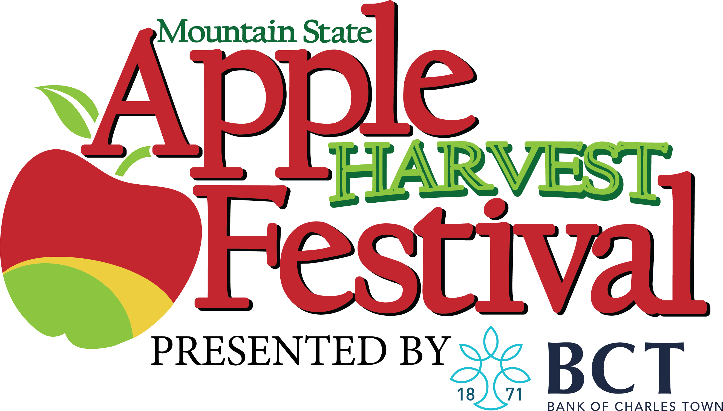
2022 Mountain State
Apple Harvest Festival
Baby Appleseed Contest

Tiny Miss and Tiny Mister Appleseed
The Baby Appleseed contest is open to boys and girls ages one week to thirty-six months as of October 15, 2022. The two contestants that are crowned Tiny Mister and Tiny Miss will receive a Crown or Tiara, Trophy, Sash, $100 cash prize, and the honor of riding in next year’s MSAHF Grand Feature Parade. Applications are available on the website.
Deadline for entry: September 17, 2022.
Winners Announcement, Sunday October 16, 2022
​
Little Miss and Little Mister Appleseed
The Little Appleseed Contest is open to boys and girls ages 3 years and 1 day to 5 years old. The two contestants that are crowned Little Mister and Little Miss will receive a Crown or Tiara, Trophy, Sash, $100 cash prize, and the honor of riding in next year’s MSAHF Grand Feature Parade. Applications are available on the website.
Deadline for entry: September 17, 2022.
Winners Announcement, Sunday October 16, 2022.
Voting is open to the general public by submitting monetary donations via our website www.msahf.com. One dollar equals one vote!
The announcement and coronation of the winners will be held at 1:00pm, Sunday, October 16th, at the Berkeley County Youth Fair Grounds. Please be sure to attend.
Voting will close PROMPTLY at 5:00pm on Saturday, October 15, 2022.
To enter: Send the entry form along with a high resolution photo of the child to info.msahf@gmail.com then pay registration online www.msahf.com
*Once registered you will be contacted with additional information.
For additional information, contact Michael Hornby by email at info.msahf@gmail.com

Entry Form
Enter early to ensure a slot for your child. The contest is limited to the first 40 entries. Entries must be postmarked by September 18th, 2022 in order to be eligible.

Contest Entered ________________________________________________________

Child’s name___________________ Age _______ Sex ____ Birth date ________

Parent’s Names _________________________________________________________

Phone number___________________________________________________________
Parent’s Address______________________________________________________

Parent’s Email Address________________________________________________

